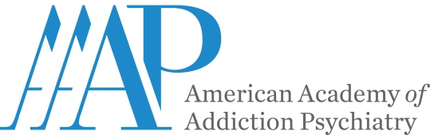
P: 401 524-3076
F: 401 272-0922
www.aaap.org
CONTACT: Miriam Giles
Director of Professional
Development and CME
NEWS RELEASE

American Academy of Addiction Psychiatry Awarded Accreditation with Commendation
EAST PROVIDENCE, Rhode Island—American Academy of Addiction Psychiatry (AAAP) has been resurveyed by the Accreditation Council for Continuing Medical Education® (ACCME) and awarded Accreditation with Commendation for six years as a provider of continuing medical education for physicians. This achievement grants AAAP accreditation through March 2022 and places the institution in the highest tier of all continuing medical education providers.
ACCME accreditation seeks to assure the medical community and the public that AAAP provides physicians with relevant, effective, practice-based continuing medical education that that supports U.S. healthcare quality improvement.
The ACCME employs a rigorous, multilevel process for evaluating institutions' continuing medical education programs according to the high accreditation standards adopted by all ACCME member organizations: the American Board of Medical Specialties, the American Hospital Association, the American Medical Association, the Association for Hospital Medical Education, the Association of American Medical Colleges, the Council of Medical Specialty Societies, and the Federation of State Medical Boards of the US, Inc.
"We commend AAAP for meeting the ACCME’s accreditation requirements and for demonstrating that it is a learning organization and a change agent for the physicians and patients it serves,” said Graham McMahon, MD, MMSc, President and CEO, ACCME. “The Academy has demonstrated that it engages in collaborative relationships with other stakeholders in the healthcare system to support quality improvement. We thank the staff and volunteers in the CME program for the work they do to make a difference and improve the health of their community."
American Academy of Addiction Psychiatry (AAAP) is the professional membership organization for learning and sharing the art and science of Addiction Psychiatry research and clinical treatment.

